

Student Financial Services

asp.net Assignment

20021179 | IT7x11 | June 9, 2017

# Introduction

* Aim of this document is to act as a reference guide towards changes that have been made to the current system. Our client at Student Financial Support (SFS), have requested that we resolve the current outstanding issues and requirements that are outlined in the proposed design brief.

The website will have a consistent look and uncluttered feel, unlike its predecessor which was unorganized in its structural layout and not very user friendly. The visitor will have a more balanced feel, when navigating the website and performing everyday tasks.

## Objectives

The objective of the website is to present the user with an easy to use interface that will be simple in design and comprehensible to use.

# Project Management

Milestones for this project include:

## Phase 1 – steps:

1. Week 1 – Start documentation and planning, such as design of interface, tables, database and master page structural layout.
2. Week 2 – Start work on constructing the frontend of the site. Write up the CSS, work on using the asp elements, asp controls and design the main template framework so that most pages will be based on this layout. Apply content to pages and construct Admin, Advisor pages with their own separate mater page and customized elements.
3. Start constructing the tables for the database, use SQL scripts for the appropriate connection strings and data sources. Start using the DML and then incorporate the DDL once queries are working and data types and references are established.
4. Week 3 – Test site and integrate with existing site, assume that there are no conflicts or bugs.

## Phase 2 – Steps:

1. During the testing period all website elements are brought together, such as current pages that need revamped and integrate them with the new system. Test compatibility.
2. Assuming that system is compatible, roll out the new system.
3. If system is not working then the final Phase 3 will be followed.

Current Issues

* Page compatibility with older system, cause them not to work properly.
* Older tables in database have been replaced with newer tables. This has cause the reports section of the site to not function, due to the disjointed tables.
* Page inheritance has become a common conflict when integrating older pages with newer pages.
* Unable to incorporate current report formulas into new system, due to the disjointed tables.

## Phase 3 – steps:

1. Week 4 – Incorporate working validation and SQL code into new pages. Make sure connection strings and data source work without any issues.
2. Resolve Issues – The reports issues were rectified, by implementing simple SQL calculation formulas.
3. Validation of Login pages were implemented, along with bug testing carried out while adding conditional logic that integrates with the SQL code.
4. Enforce data integrity by using foreign keys and constraints were implemented.
5. Make update changes to tables, by making sure data types are compatible.
6. Tidy up any errors or bugs that plague the system and prepare for rollout
7. Deploy website into system

# Interface Design

## Login page

Interactive design involves the user being presented with the Main splash page for logging into the system. The page gives the user 4 options:

1. Advisor Login – This consists of two textbox fields, one for Username and the other for Password.
2. Admin Login – This text hyper link, takes user to the Admin login section. User will be presented with the Username and Password input fields.
3. Forgot Password – This text link will take user to the Forgotten Password form. The form will prompt the user for their correct Username, before showing the password to the user.
4. About – Is used as a help page that contains instructions on how the system works.

## Advisor Login

* User must input the correct credentials that were provided to the user from the Administrator.
* Once the above is complete, the user will enter the Main Advisor management webpage. Page will present user with a menu giving him or her options.
* The Main Advisor page also has a Search Student option, that always the user to enter the required identification number that relates to that particular student of interest.

## Admin Login

* User must input the correct credentials that were provided to the user from the Administrator.
* Once the above is complete, the user will enter the Main Admin webpage. Page will present user with a menu giving him or her options.

## forgot password

* User must provide the correct Username before the password is displayed
* Once the above is complete, the user redirected to the Login page.

## about

* This page acts as an instructional menu.

# Advisor Menu

This consists of the following page links:

* Home – Take user back to the Main Advisor page.
* Manage Student – This is a dropdown style menu, consisting of nested sub menus.
* Edit Student (Sub menu) – Gives user options to edit a student.
* Add Notes (Sub menu) – Displays text that user may wish to update.
* Add Student (Sub menu) – Advisor can update Student information here or add new Student to enrolment.
* Allocate Funds – User can set the amount of funds that maybe required.
* Reports – Displays summary reports on finances and trends.
* Logout – Takes user back to Main login page.

# Advisor Pages

## Manage student

This page displays the following entities:

* Faculty Name
* Program Name and Skill Level
* Course Name
* Faculty Name
* Location

These above tables can be viewed, so that if there are any changes the Advisor will be kept up to date.

## Edit student

This page provides the user with edit and delete options that that can use for makes changes to Student records. (Image)

## Add notes

Temporary page that is used as a place holder for future content, which may be added to the functionality of the system for any required updates. (Image)

## Add student

Gives the users the options of delete, update and new. (Image)

## Allocate funds

Gives the users the options of delete, update and new. (Image)

## Reports

Displays current revamped reports with links that display the results. (Image)

# Advisor - Login Page Validation

User must fill in both text boxes, Username (txtUsername) and Password (txtPassword)

1. If button clicked when field is left blank, an error message appears, prompting the user to enter in data.
2. If one or both field inputs are invalid, an error messages appears.

# Admin Menu

This consists of the following page links:

* Main – Take user back to the Main Admin page.
* Edit Advisor – This is takes user to the profile section of the Advisor. Admin can make appropriate changes when need be.
* Edit Faculty – Takes user to the Faculty.aspx page and gives options to edit a Faculty.
* Edit Course – User is taken to this page, were they can make changes
* Edit Funds – Admin is taken to Funds page, were he / she can update Fund information.
* Edit Grants – User can edit these if need be, once taken to the Grants page.
* Edit Program – Displays the current programs, maybe update if applicable.
* Logout – Takes user back to Main login page.

# Admin Pages

## edit advisor

This page displays the following options:

* Delete (Erase field)
* Update (Edit record)
* Insert (New record)

These above options give the Administrator the ability to makes changes, when required.

## Edit faculty

This page provides the user with edit, update and delete options that can be used to makes changes to Faculty records.

## Edit course

This page provides the user with edit, update and delete options that can be used to makes changes to Course records.

## edit funds

Gives the users the options of delete, update and new.

## edit grants

This page provides the user with edit, update and delete options that can be used to makes changes to Grant records.

## edit program

This page provides the user with edit, update and delete options that can be used to makes changes to Program records.

# Admin – Login Page Validation

User must fill in both text boxes, Username (txtUsername) and Password (txtPassword)

1. By clicking on the Admin Login link, on the Main Login page, user is taken to the Admin Login form.
2. If button clicked when field is left blank, an error message appears, prompting the user to enter in data.
3. If one or both field inputs are invalid, an error messages appears.
4. Error message will be displayed if a numerical character is input into the field.

# Structure and Functionality

## Login Page

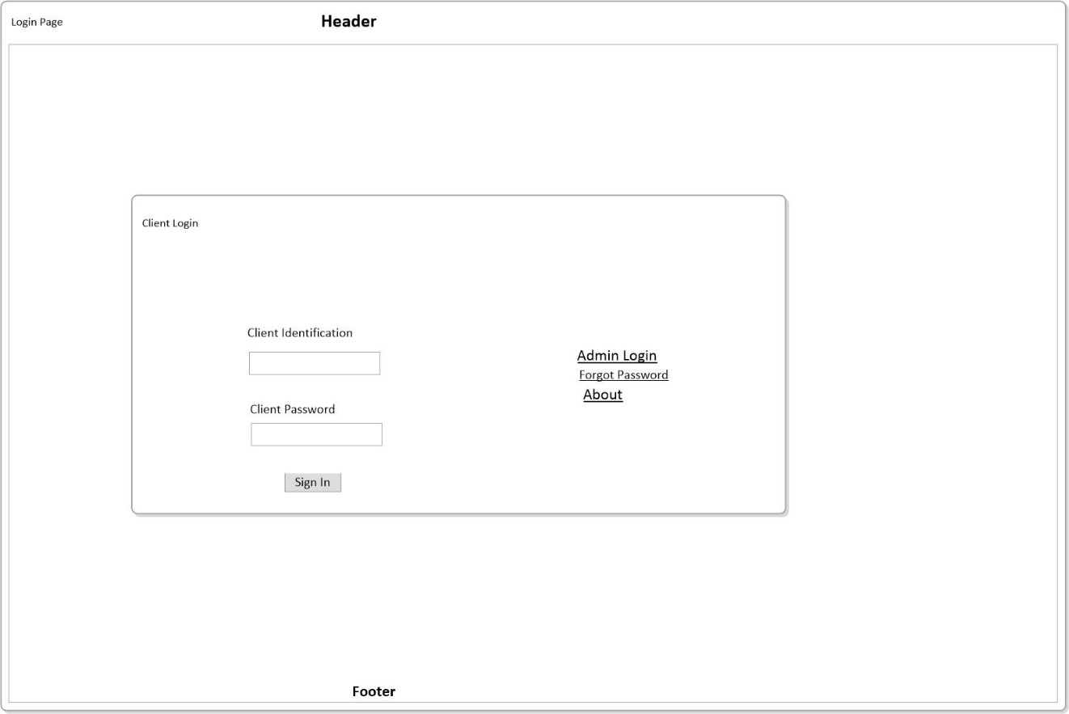

1. Advisor – Enter in Username into the txtUsername textbox field. If Username is valid then enter password. You will be prompted to enter the required field if validation is incorrect. If both fields are valid, user will be taken to the Advisor page.
2. Admin Login – The link on this form will take user to a separate secure login section. Validation will be same as above, once correctly validated user will be logged into the Admin main page.
3. Forgot Password – Link will take user to the ForgotPW.aspx page. A required user will be prompted for. Once successful the user will be shown the password.
4. About -This is a help page with instructions for basic use.

# Advisor – Main Page

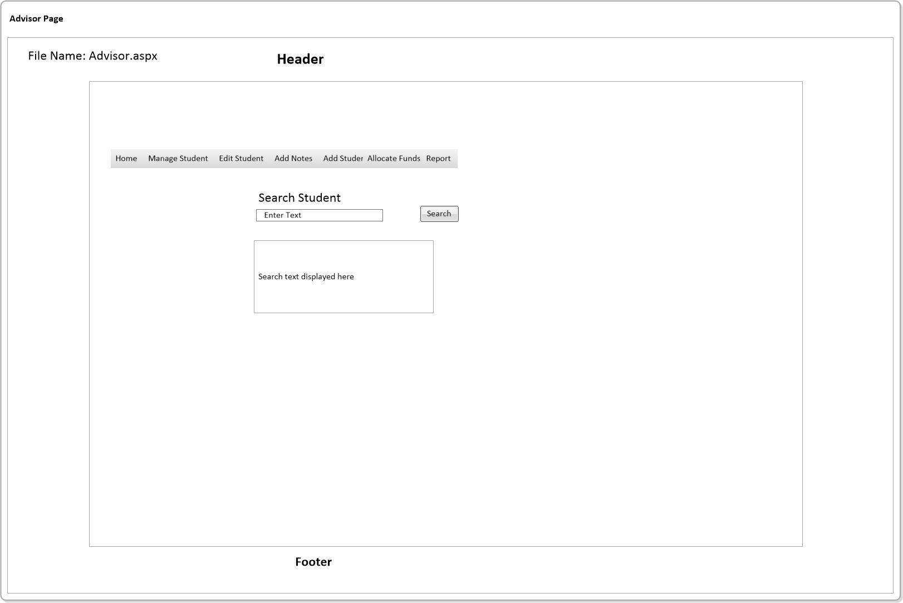

## menu – advisor main page

* Home – Main page for user
* Manage Student – Dropdown menu
* Allocate Funds – Link to page for editing finances
* Reports – Takes user to a reports summary page
* Edit Student – User is directed to the Student records page
* Add Notes – A reserved section of the site, intended to be used once new system is successfully implemented
* Add Student – Link takes user to a page that gives user the ability to add a new record or records

## Advisor – home page

1. Advisor can enter Student Identification number into the search box Textbox field: TextBoxStudentID.
2. Once search button is click, information will be displayed in a text field name: ListboxStudentDetails.

## Advisor – manage student

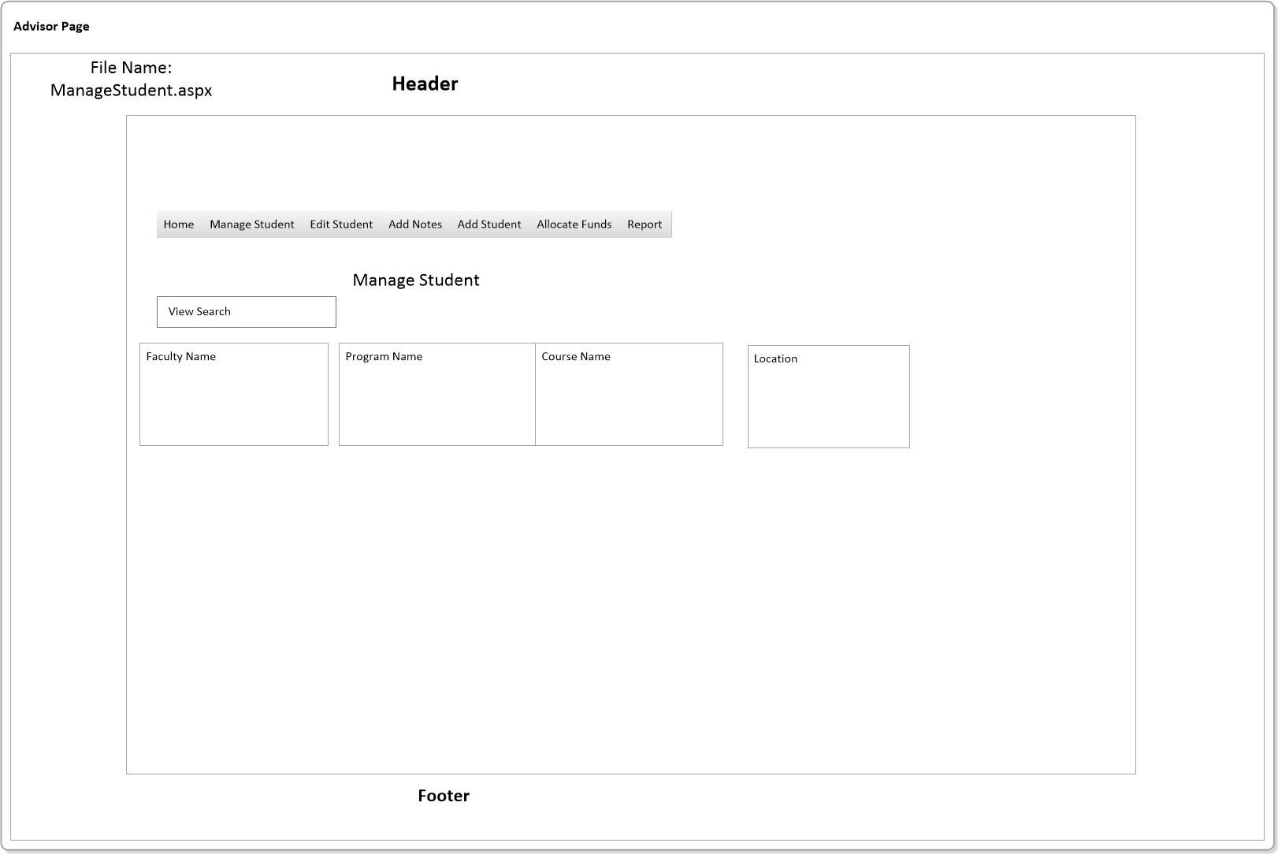

The above table ManageStudent.aspx, displays the current records that are being implemented. This allows the user to keep track of any changes and to be kept updated on all records.

## Advisor – edit student

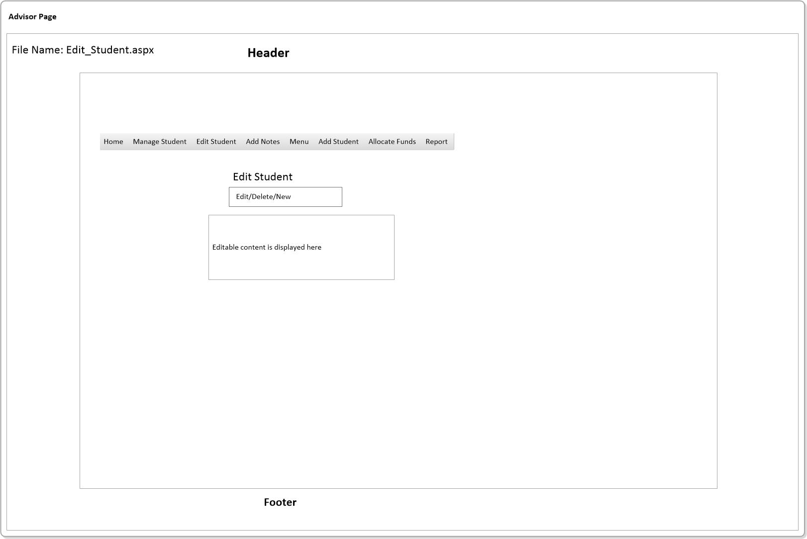

1. Displays current Student records.
2. Permissions assigned are edit and delete. Any changes that are needed can be applied here.
3. Page contains a pages link that take user from one record to another, options available for user are being able to update records or cancel the current operation.

## Advisor – Add Notes

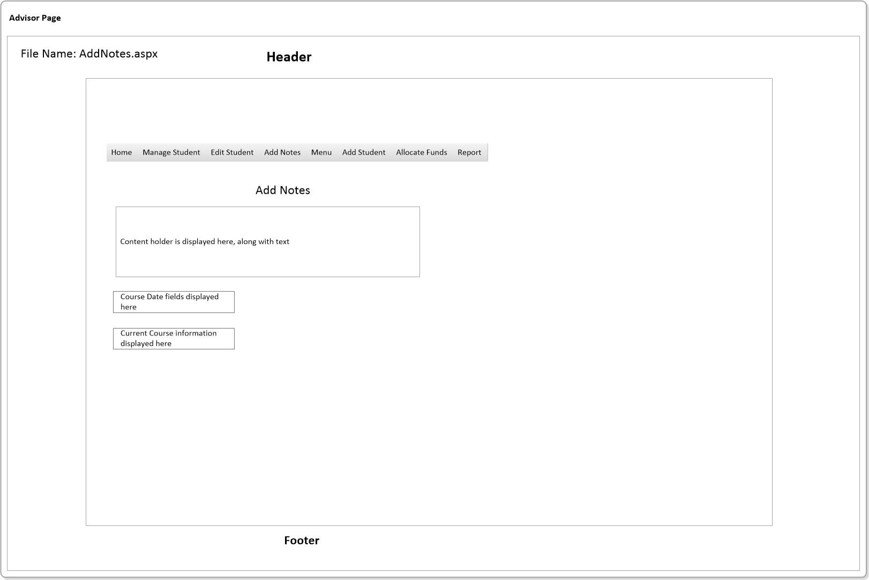

* The default content is used as a holding place for any possible future updates. Course content is displayed on this page, so that user knows which courses are available.

## Advisor – add student

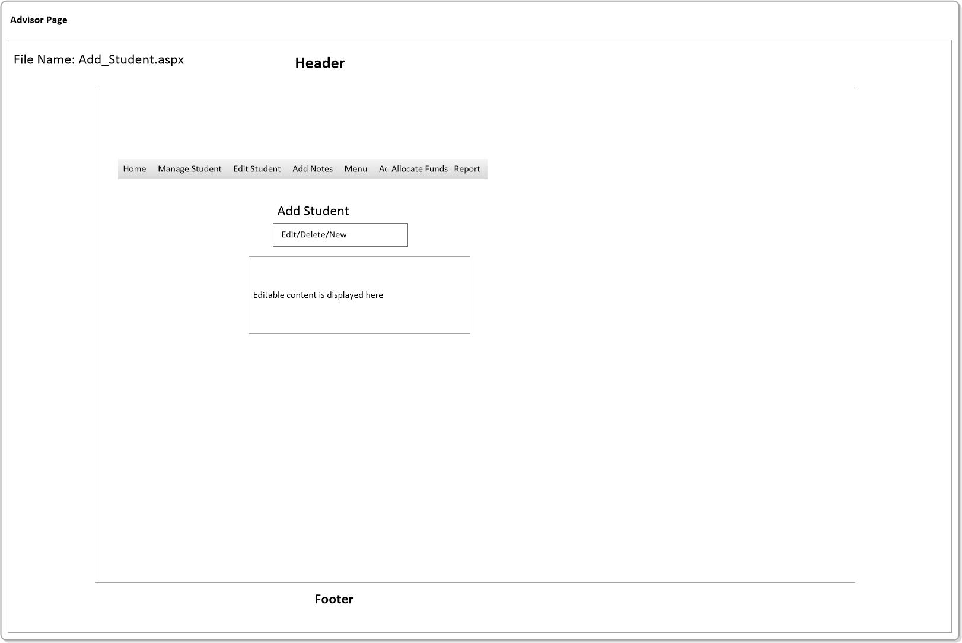

* The above displays the current Student or Students, functionality of edit, delete are added so that user can make any changes that need to be implemented. Similar functionality to the previous section.

## Advisor – allocate funds

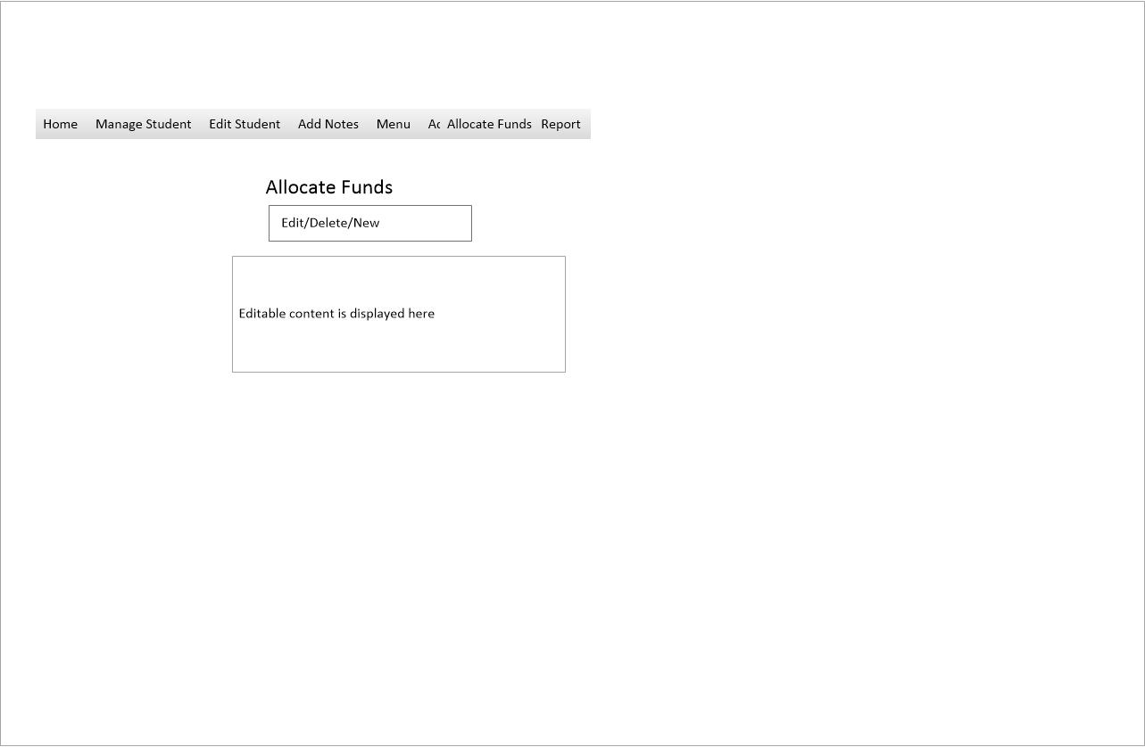

* The above displays Koha Funds and all relevant information.
* Contains DUI Functionality (delete, update, insert).

## Advisor – report

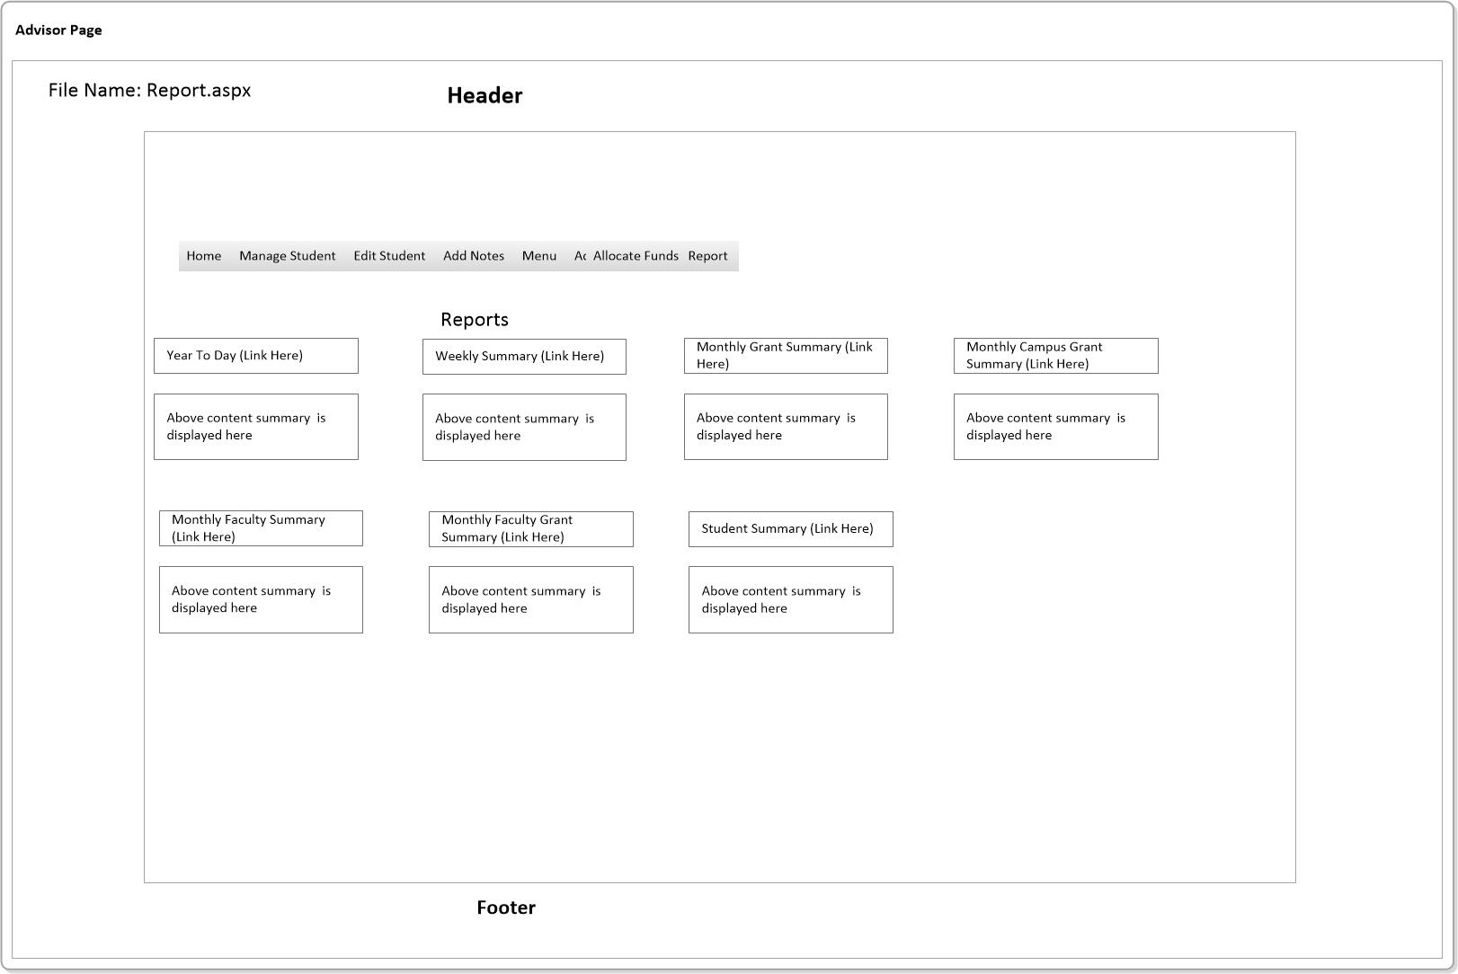

Reports – Will be displayed once a link has been clicked on. Following links are as follows:

* Year To The Day – Shows Kuha Funds when clicked
* Weekly Summary – Displays the sum of the weekly funds
* Monthly Grant Summary – Shows the allocation total of grants
* Monthly Campus Grant Summary – Shows the total value combined
* Monthly Faculty Summary – Shows the name along with the total
* Month Faculty Grant Summary – Display grant grantotal
* Student Summary – Displays a summary of Student gender, age and ethnicity

Issue: Compatibility with the Year() function inside Visual Studio, was an issue as this command was not recognized. The formula for this was supposed to work out the age of the recipient.

SQL with issue:

Select

DateOfBirth,

YEAR(DateOFBirth) AS [BirthYear],

YEAR(GETDATE())AS [ThisYear], YEAR(GETDATE())-YEAR(DateOfBirth)As [Age] from Student

## Admin – Main Page

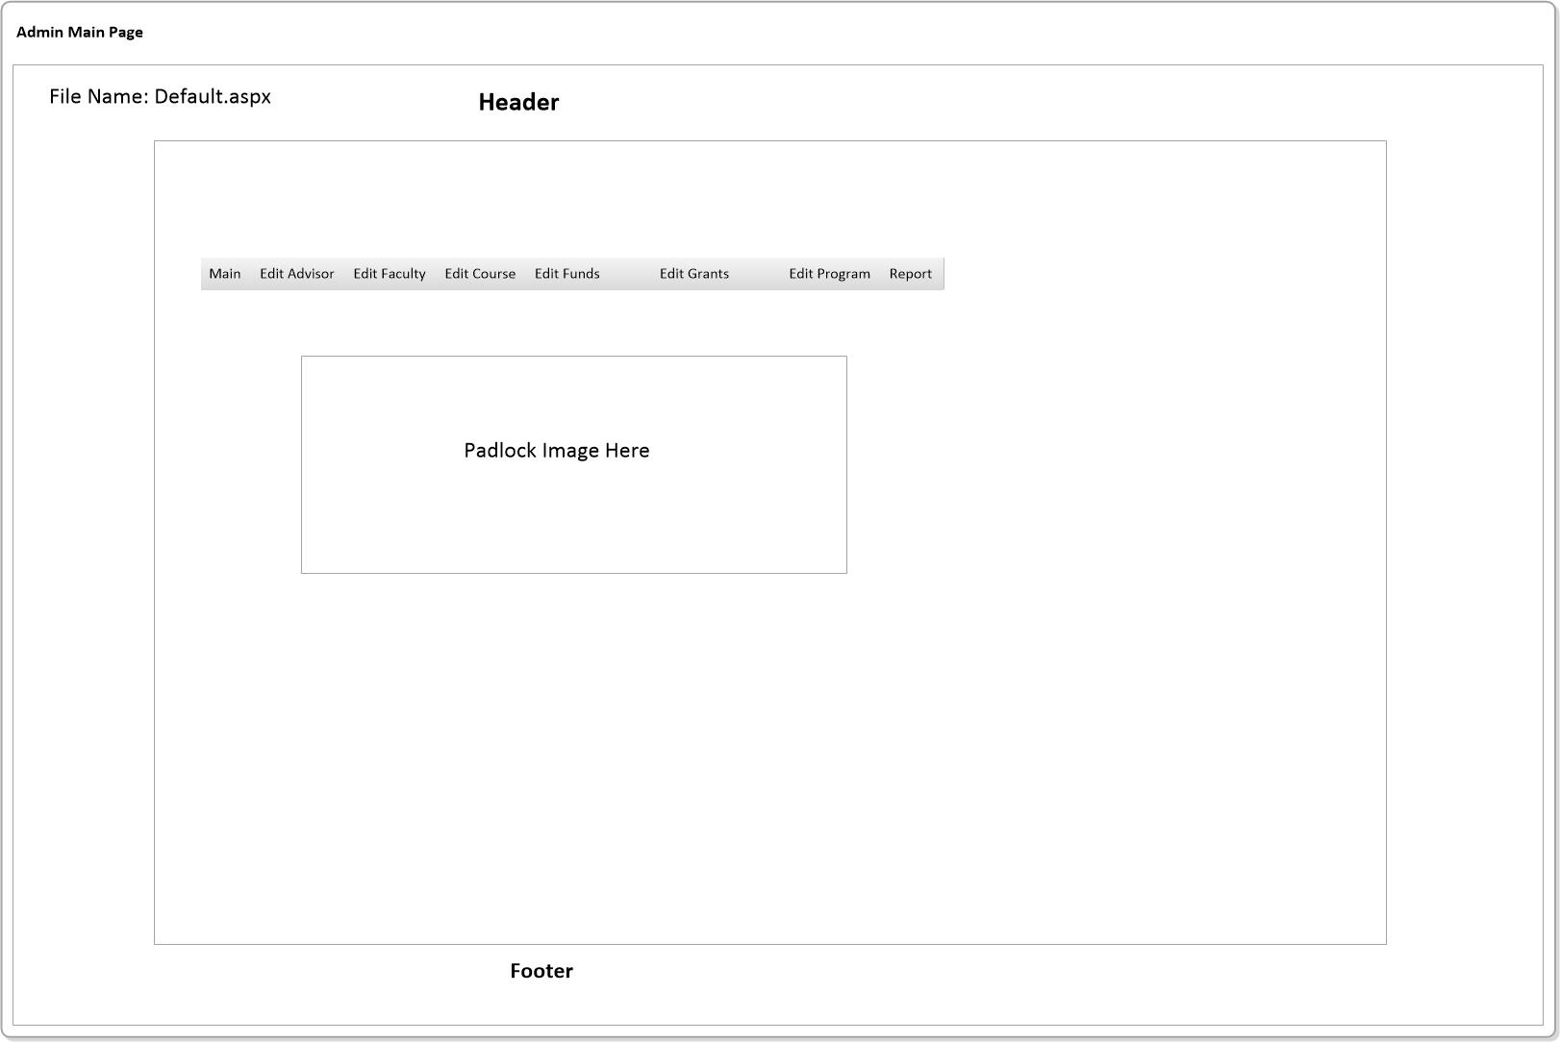

## Admin – Menu

* Main – Main page
* Edit Advisor – Page used for editing an Advisor, such as changing password.
* Edit Faculty – Takes user to the Faculty page, which provides user options to edit desired Faculty.
* Edit Course – Course page contains current courses that maybe edited if required.
* Edit Fund – Takes user to the Fund page for editing purposes.
* Edit Grant – Grant page offers the user the capability to edit if need be.
* Edit Program – Similar use as above.

## admin - Edit Advisor

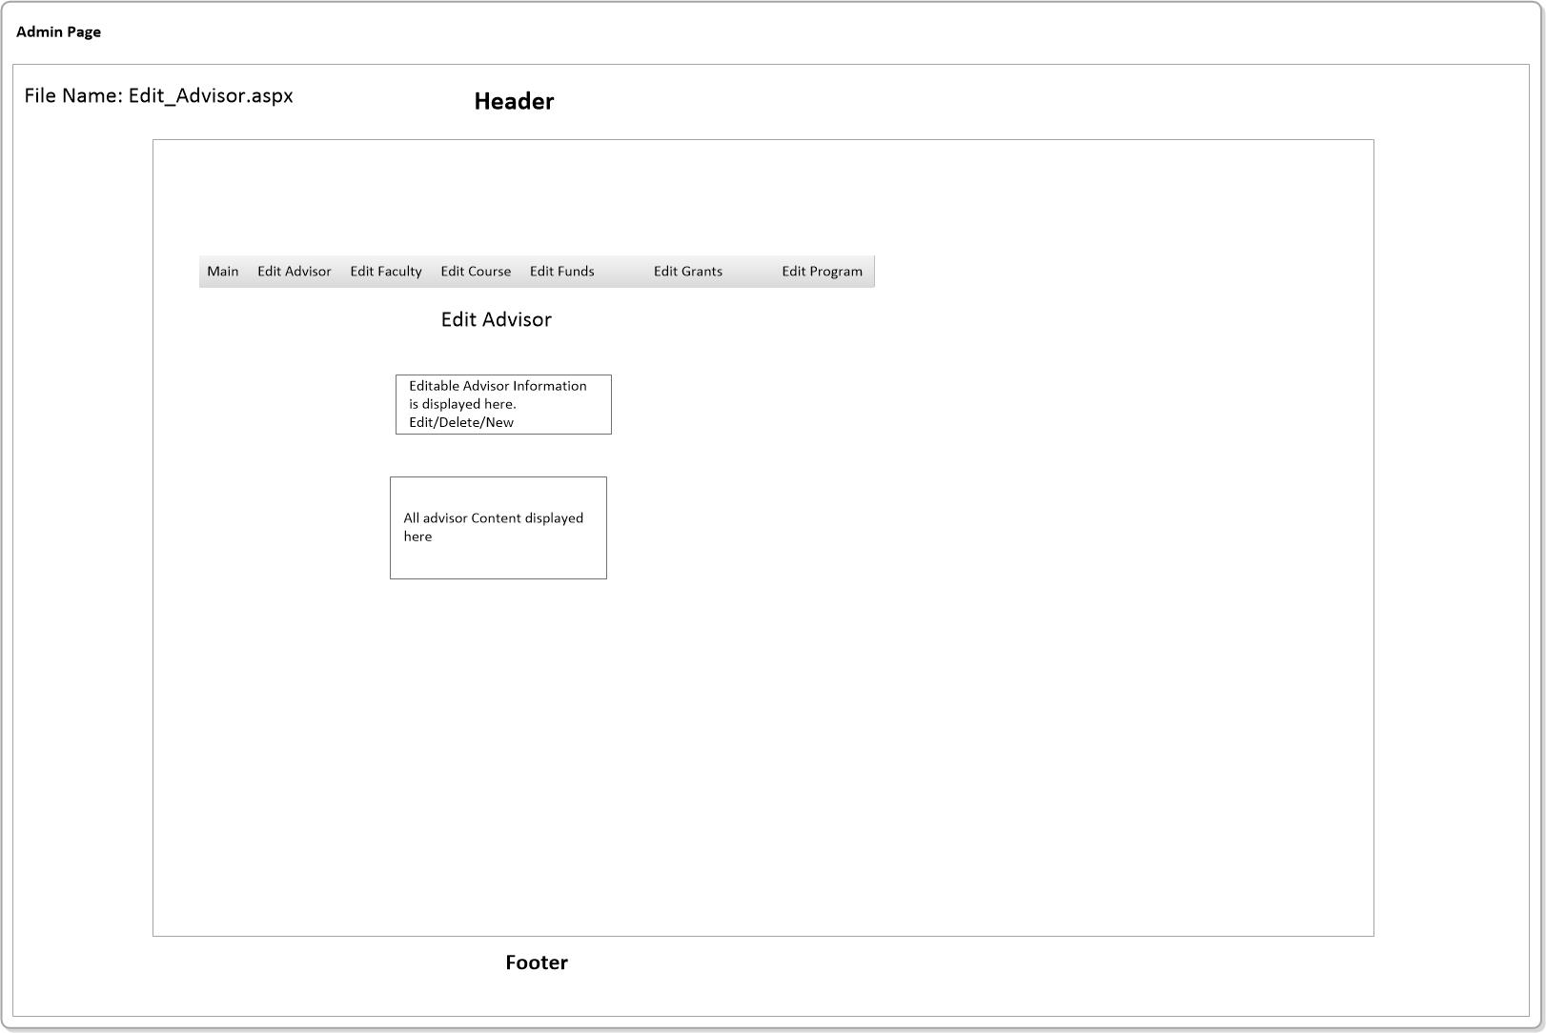

* Provides the following functionality; edit, delete and new (insert new record)
* Content is displayed in a text field.

## admin - Edit faculty

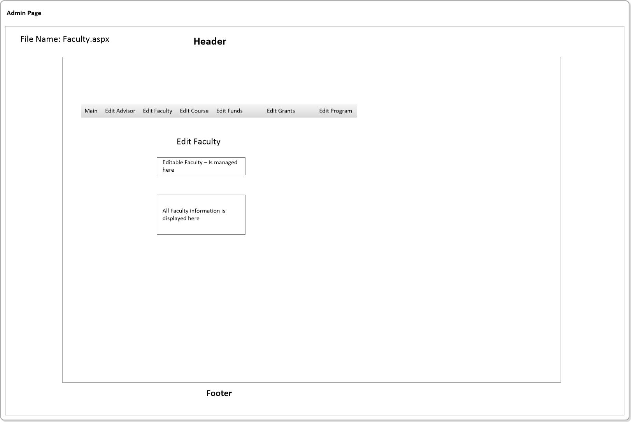

* Provides the following functionality; edit, delete and new (insert new record)
* Content is displayed in a text field.

## Edit course

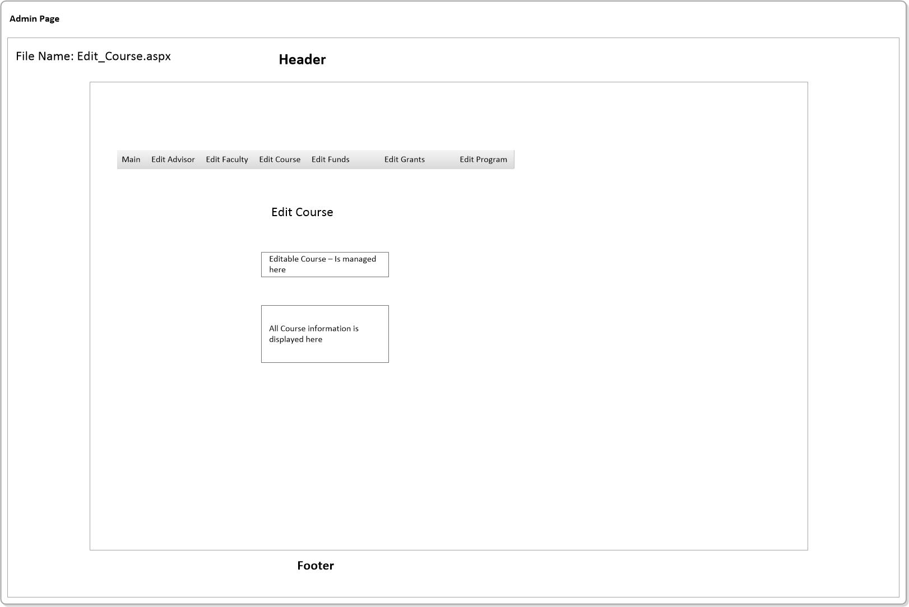

* Provides the following functionality; edit, delete and new (insert new record)
* Content is displayed in a text field.

## Admin – Edit Funds

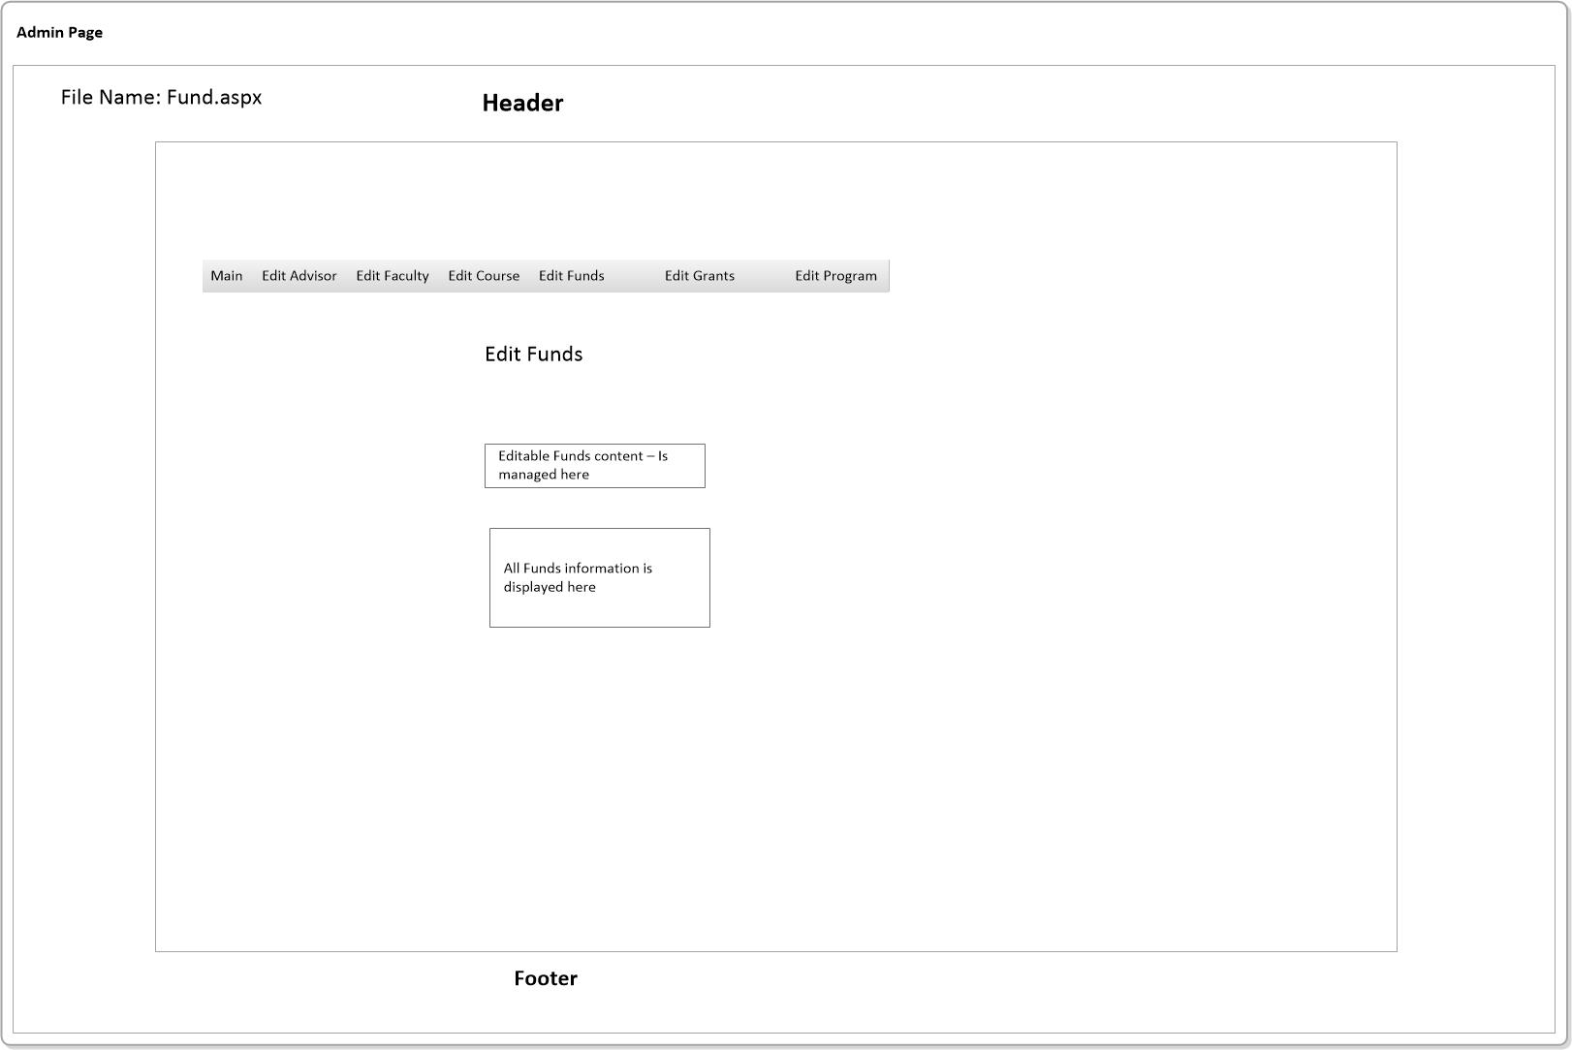

* Provides the following functionality; edit, delete and new (insert new record)
* Content is displayed in a text field.

## Admin – Edit Grants

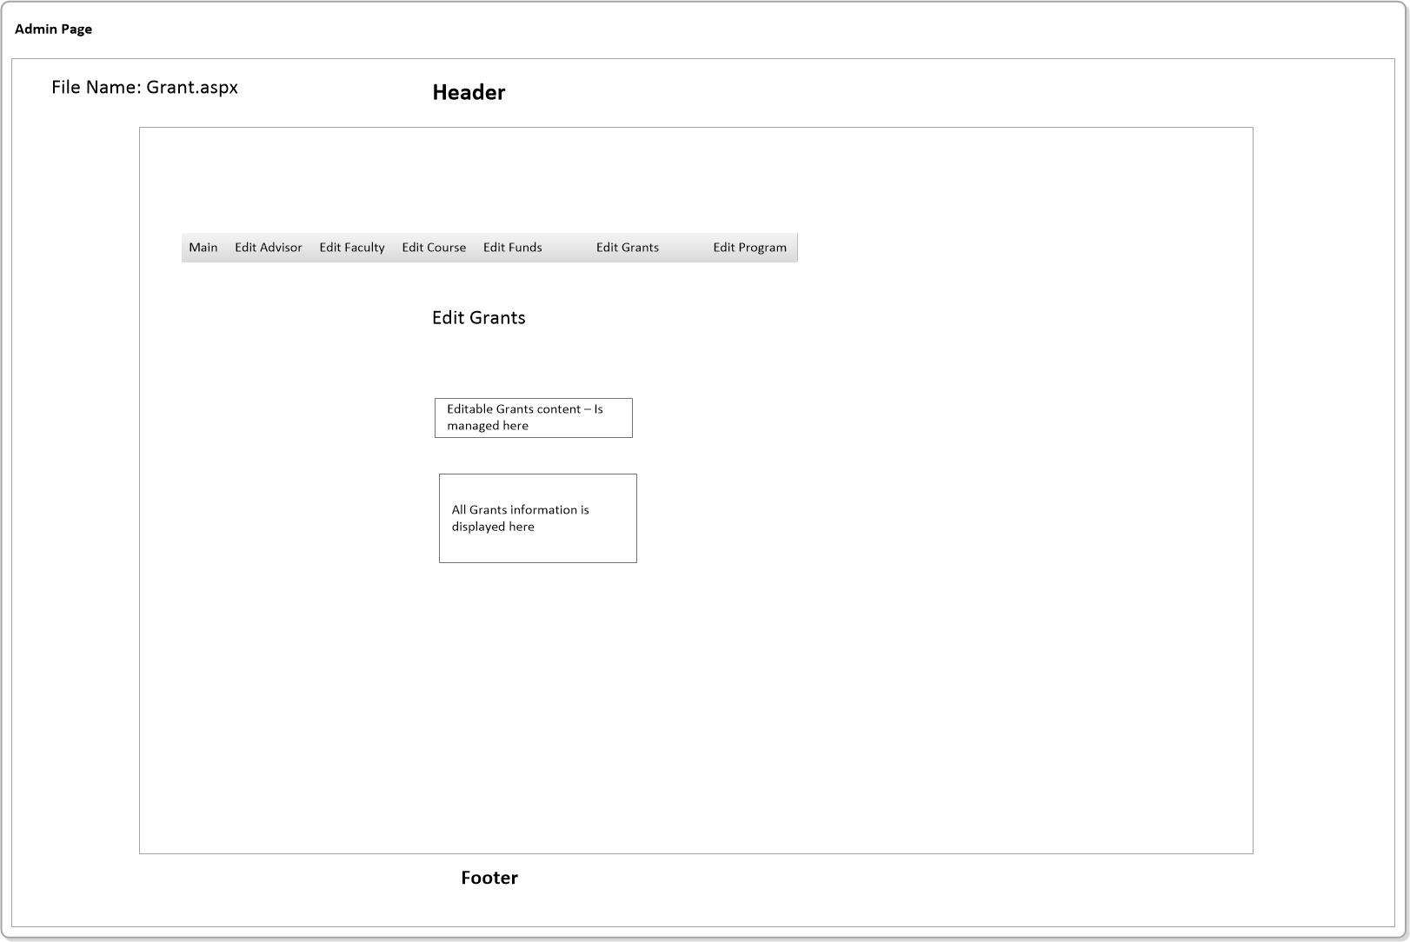

* Provides the following functionality; edit, delete and new (insert new record)
* Content is displayed in a text field.

## Admin – edit program

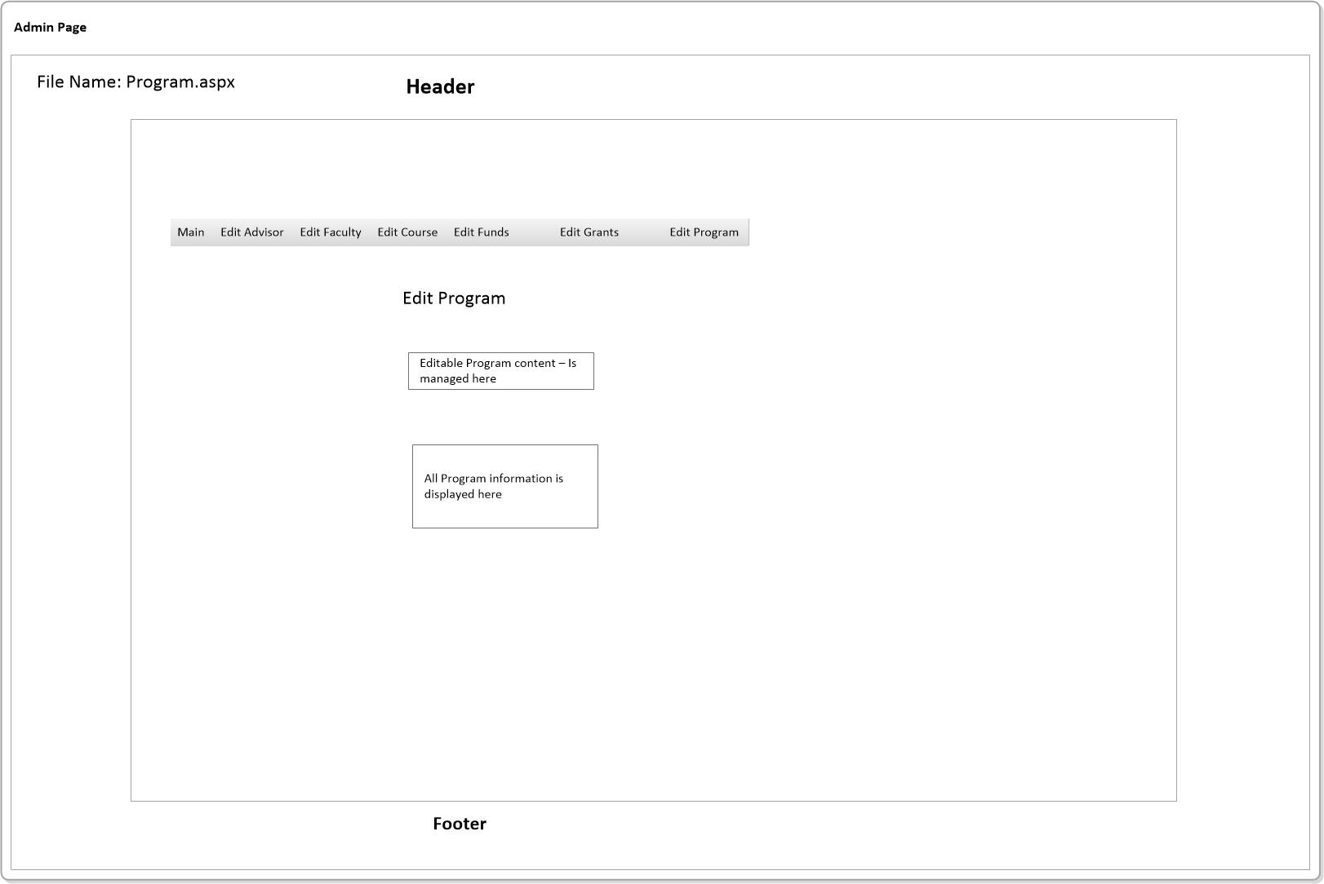

* Provides the following functionality; edit, delete and new (insert new record)
* Content is displayed in a text field.

# Database Design

